Base Edge
# Source: AI Source: Provided by: [Data Path: Persons Table -> ID Column: 1, Name_En Column: Motasem Essam] -> From: [ChatGPT] on [7/25/2026]
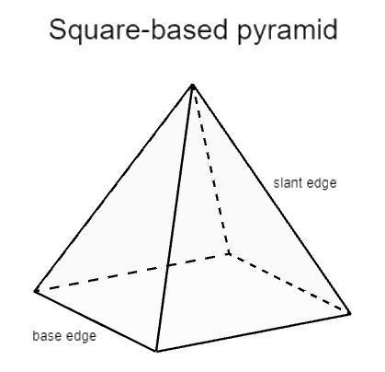
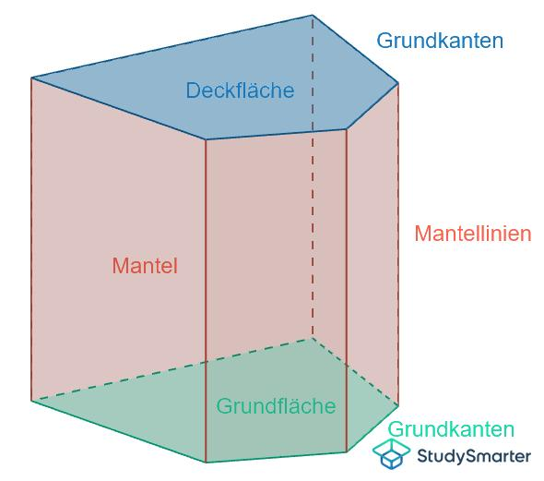
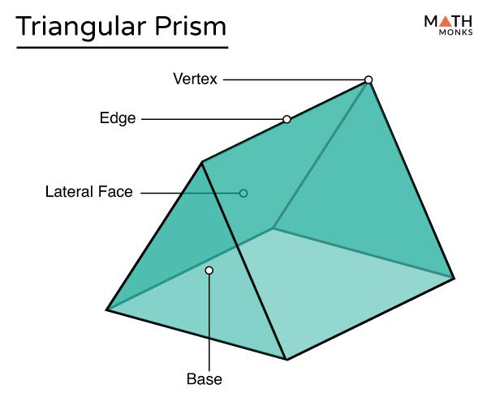

Definition
# Source: AI Source: Provided by: [Data Path: Persons Table -> ID Column: 1, Name_En Column: Motasem Essam] -> From: [ChatGPT] on [7/25/2026]
A base edge in solid geometry is an edge that belongs to the base of a three-dimensional solid. It is a line segment where two boundary portions of the base meet, typically two sides of a polygonal base.
Base edges are especially important in prisms, pyramids, and other polyhedra because they define the outline of the base and help determine the solid's dimensions, shape, and surface area.
For example, a square pyramid has four base edges because its square base has four sides.

Simple definition
# Source: AI Source: Provided by: [Data Path: Persons Table -> ID Column: 1, Name_En Column: Motasem Essam] -> From: [ChatGPT] on [7/25/2026]
A base edge is one of the line segments forming the boundary of a solid's base.
Examples:
- A triangular prism has three edges on each triangular base.
- A square pyramid has four base edges.
- A pentagonal prism has five edges on each pentagonal base.

Classification tree
# Source: AI Source: Provided by: [Data Path: Persons Table -> ID Column: 1, Name_En Column: Motasem Essam] -> From: [ChatGPT] on [7/25/2026]
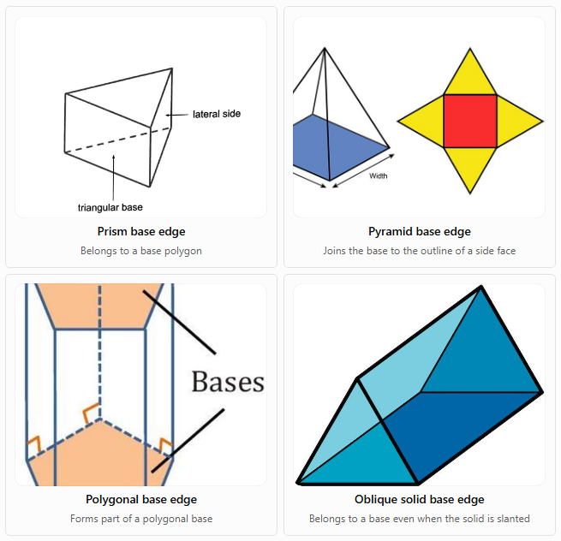
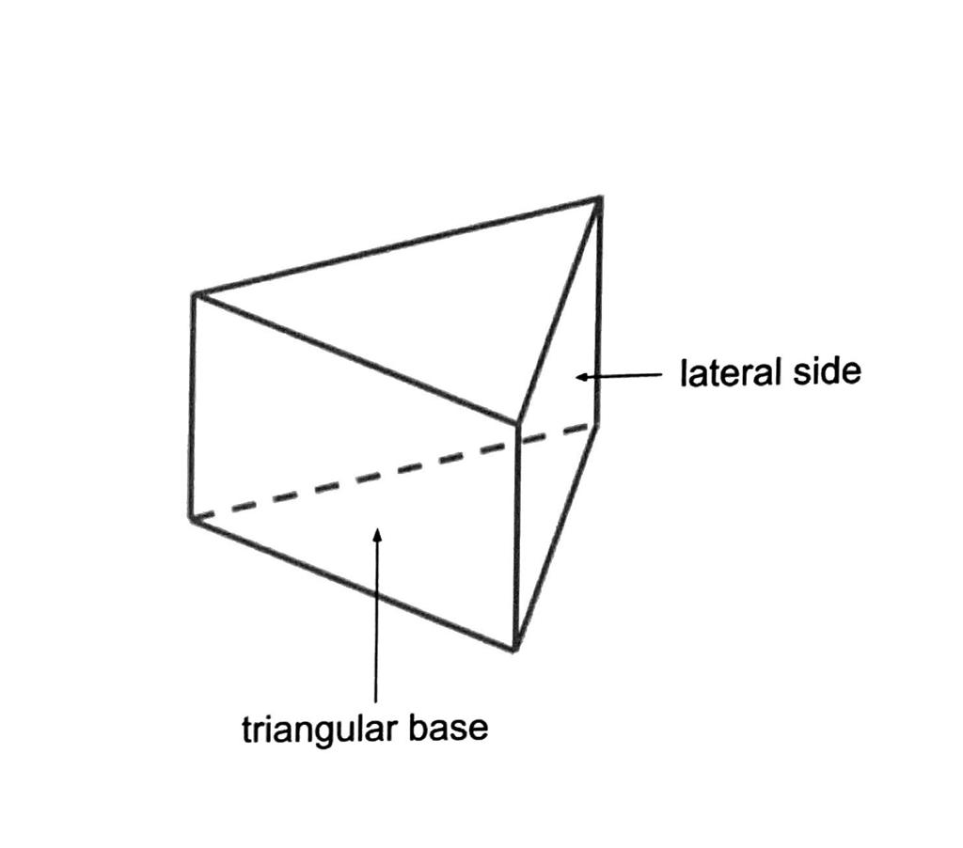
Prism base edge
Belongs to a base polygon
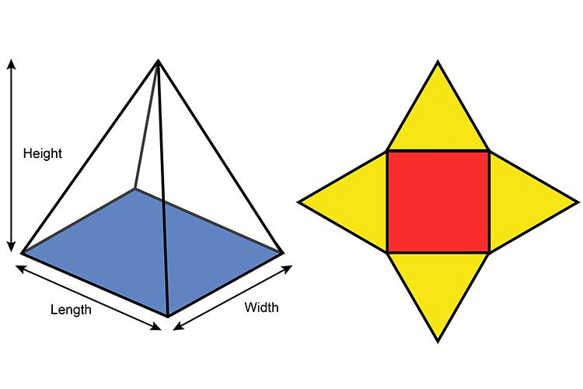
Pyramid base edge
Joins the base to the outline of a side face
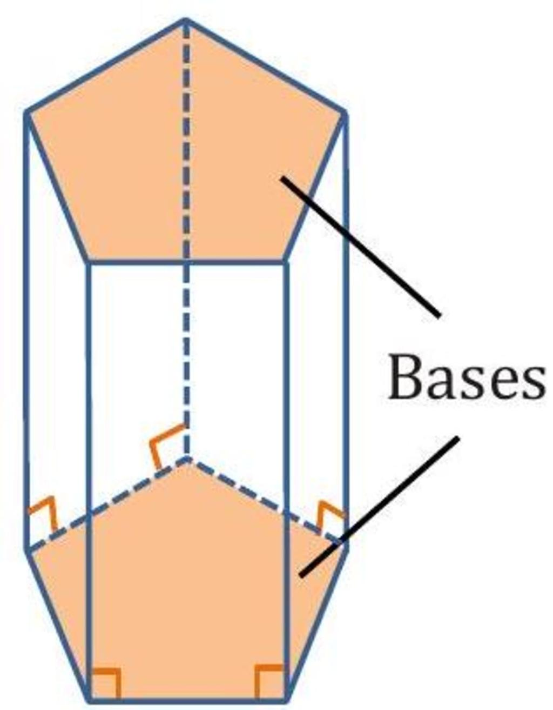
Polygonal base edge
Forms part of a polygonal base
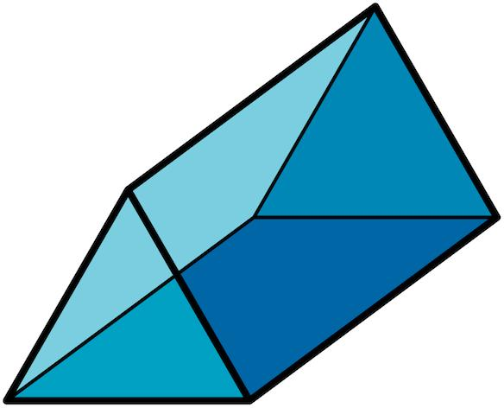
Oblique solid base edge
Belongs to a base even when the solid is slanted
These are examples of base edges in different solids, not separate universally standardized categories.

Key characteristics
# Source: AI Source: Provided by: [Data Path: Persons Table -> ID Column: 1, Name_En Column: Motasem Essam] -> From: [ChatGPT] on [7/25/2026]
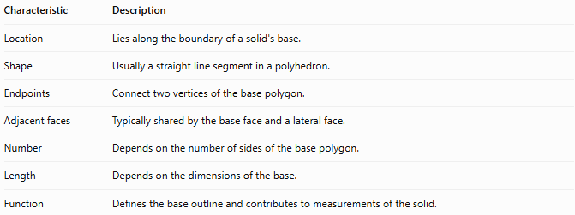
Characteristic | Description
Location | Lies along the boundary of a solid's base.
Shape | Usually a straight line segment in a polyhedron.
Endpoints | Connect two vertices of the base polygon.
Adjacent faces | Typically shared by the base face and a lateral face.
Number | Depends on the number of sides of the base polygon.
Length | Depends on the dimensions of the base.
Function | Defines the base outline and contributes to measurements of the solid.

Geometric representation
# Source: AI Source: Provided by: [Data Path: Persons Table -> ID Column: 1, Name_En Column: Motasem Essam] -> From: [ChatGPT] on [7/25/2026]
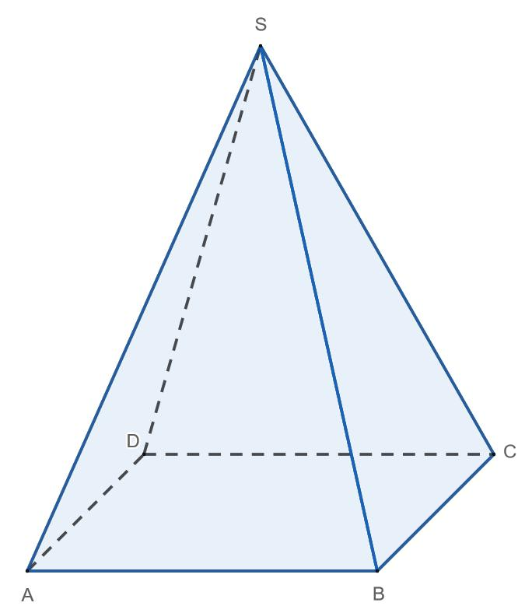
Consider a square pyramid with base $ABCD$ and apex $S$.
Its base edges are:
- $AB$
- $BC$
- $CD$
- $DA$
These four edges form the square base. The edges $SA$, $SB$, $SC$, and $SD$ connect the apex to the base vertices and are called lateral edges, not base edges.
Base edges in other solids

A. Triangular prism
# Source: AI Source: Provided by: [Data Path: Persons Table -> ID Column: 1, Name_En Column: Motasem Essam] -> From: [ChatGPT] on [7/25/2026]
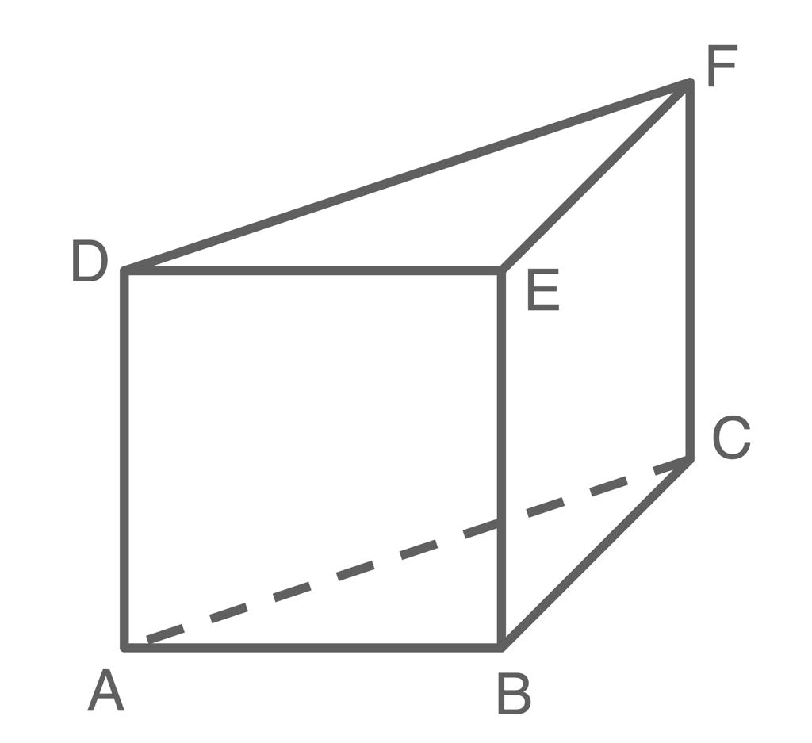
Each triangular base has three base edges. The prism has six base edges in total across its two bases.

B. Hexagonal prism
# Source: AI Source: Provided by: [Data Path: Persons Table -> ID Column: 1, Name_En Column: Motasem Essam] -> From: [ChatGPT] on [7/25/2026]
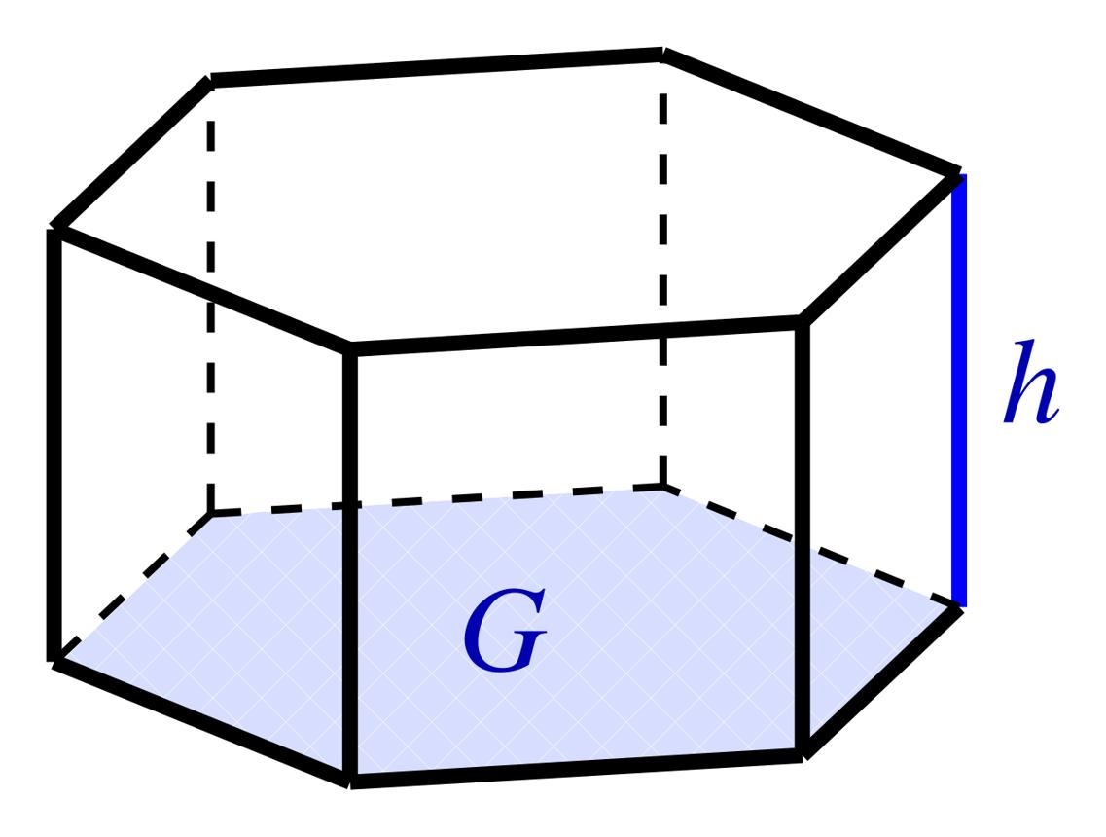
Each hexagonal base has six base edges, giving twelve base edges across both bases.

C. Rectangular prism
# Source: AI Source: Provided by: [Data Path: Persons Table -> ID Column: 1, Name_En Column: Motasem Essam] -> From: [ChatGPT] on [7/25/2026]
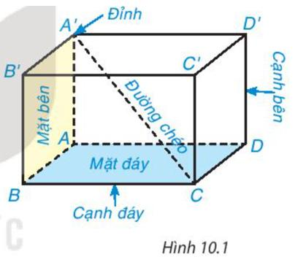
Each rectangular base has four base edges. The prism has eight base edges in total across its two bases.

Mathematical representations

A. Number of base edges
# Source: AI Source: Provided by: [Data Path: Persons Table -> ID Column: 1, Name_En Column: Motasem Essam] -> From: [ChatGPT] on [7/25/2026]
For a prism with an $n$-sided polygonal base, each base has $n$ edges. Since a prism has two bases:
$$\boxed{E_{\text{base}}=2n}$$
For a pyramid with an $n$-sided polygonal base, there is one base, so:
$$\boxed{E_{\text{base}}=n}$$
where $n$ is the number of sides of the base polygon.

B. Length of a base edge
# Source: AI Source: Provided by: [Data Path: Persons Table -> ID Column: 1, Name_En Column: Motasem Essam] -> From: [ChatGPT] on [7/25/2026]
For a square base with side length $a$, each base edge has length:
$$\boxed{e=a}$$
For a regular $n$-sided polygon with perimeter $P$, each base edge has length:
$$\boxed{e=\frac{P}{n}}$$
This second formula applies when all sides of the base are equal.

C. Perimeter of the base
# Source: AI Source: Provided by: [Data Path: Persons Table -> ID Column: 1, Name_En Column: Motasem Essam] -> From: [ChatGPT] on [7/25/2026]
The perimeter is the sum of all base-edge lengths.
$$\boxed{P=\sum_{i=1}^{n}{e_{i}}}$$
For a regular polygon:
$$\boxed{P=ne}$$
where $e$ is the common base-edge length.

Worked examples
# Source: AI Source: Provided by: [Data Path: Persons Table -> ID Column: 1, Name_En Column: Motasem Essam] -> From: [ChatGPT] on [7/25/2026]
Example 1: Base edges of a hexagonal prism
A hexagonal prism has two hexagonal bases. How many base edges does it have in total?
Step 1: Identify the number of sides of each base.
$$n=6$$
Step 2: Use the prism formula.
$$E_{\text{base}}=2n=2\left(6\right)=12$$
Answer: The hexagonal prism has 12 base edges across its two bases.
Example 2: Base edges of a pentagonal pyramid
A pentagonal pyramid has a pentagonal base. How many base edges does it have?
A pentagon has five sides. Therefore,
$$E_{\text{base}}=n=5$$
Answer: The pentagonal pyramid has 5 base edges.
Example 3: Finding the base perimeter
A regular hexagonal prism has a base-edge length of $4\text{ cm}$. Find the perimeter of one base.
Step 1: A hexagon has six edges.
Step 2: Multiply the number of edges by the length of each edge.
$$P=ne=6\left(4\right)=24\text{ cm}$$
Answer: The perimeter of one base is $\boxed{24\text{ cm}}$.

Comparison with related edge types
# Source: AI Source: Provided by: [Data Path: Persons Table -> ID Column: 1, Name_En Column: Motasem Essam] -> From: [ChatGPT] on [7/25/2026]
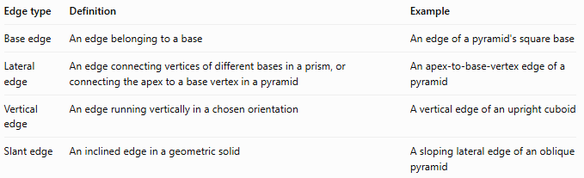
Edge type | Definition | Example
Base edge | An edge belonging to a base | An edge of a pyramid's square base
Lateral edge | An edge connecting vertices of different bases in a prism, or connecting the apex to a base vertex in a pyramid | An apex-to-base-vertex edge of a pyramid
Vertical edge | An edge running vertically in a chosen orientation | A vertical edge of an upright cuboid
Slant edge | An inclined edge in a geometric solid | A sloping lateral edge of an oblique pyramid
Important: “Vertical” and “slant” describe orientation or position, whereas “base edge” describes an edge's relationship to the base. A base edge is not necessarily horizontal in every orientation.

Applications
# Source: AI Source: Provided by: [Data Path: Persons Table -> ID Column: 1, Name_En Column: Motasem Essam] -> From: [ChatGPT] on [7/25/2026]
Base edges are useful in:
- Surface-area calculations: determining the dimensions of the base and adjacent faces.
- Perimeter calculations: finding the outline length of polygonal bases.
- Construction: measuring the base framework of roofs, pyramids, and structural models.
- 3D modeling: defining polygonal faces and connecting their vertices.
- Geometry problems: counting edges and distinguishing base edges from lateral edges.

Key points
# Source: AI Source: Provided by: [Data Path: Persons Table -> ID Column: 1, Name_En Column: Motasem Essam] -> From: [ChatGPT] on [7/25/2026]
- A base edge belongs to the boundary of a solid's base.
- A polygonal base with $n$ sides has $n$ base edges.
- A prism has two bases, so it has $2n$ base edges in total.
- A pyramid has one base, so it has $n$ base edges.
- Base edges differ from lateral edges, which connect the base to other parts of the solid.
- Base-edge lengths help determine base perimeter, area, and other dimensions.

Conclusion
# Source: AI Source: Provided by: [Data Path: Persons Table -> ID Column: 1, Name_En Column: Motasem Essam] -> From: [ChatGPT] on [7/25/2026]
A base edge in solid geometry is a line segment forming part of the boundary of a solid's base. Identifying base edges helps us describe the structure of prisms and pyramids, count their edges, and calculate dimensions such as base perimeter.

